Test Progress Report

🔹 Definition
# Source: Chatgpt (GPT-5-Standard) at [8/18/2025]
A Test Progress Report is a type of test report that communicates the current status of testing activities during a project or release. It helps stakeholders track how much work has been done, what remains, and whether testing is on track.

🎯 Purpose of Test Progress Report
# Source: Chatgpt (GPT-5-Standard) at [8/18/2025]
- Show the current state of test execution.
- Track progress against the test plan & schedule.
- Highlight defects discovered & fixed.
- Identify risks, delays, and blockers.
- Support management decisions (e.g., continue, add resources, delay release).

📦 Contents of a Test Progress Report
# Source: Chatgpt (GPT-5-Standard) at [8/18/2025]
Typical sections include:
- Project Information
  - Project name, release/build version, report date.
- Test Execution Status
  - Planned vs executed test cases.
  - Pass, fail, blocked, not executed.
  - Percentage completion.
- Defect Status
  - Number of open, closed, resolved, by severity/priority.
- Coverage Information
  - Requirements covered vs uncovered.
  - Modules/features tested so far.
- Environment Status
  - Any issues with test environments, tools, or data.
- Risks & Issues
  - Risks that might impact progress.
  - Blockers preventing execution.
- Next Steps
  - Activities planned for upcoming days/weeks.

📊 Example Test Progress Report (Summary Table)
# Source: Chatgpt (GPT-5-Standard) at [8/18/2025]
Project: Banking App – Release 2.0
Date: 18-Aug-2025
Prepared By: QA Lead
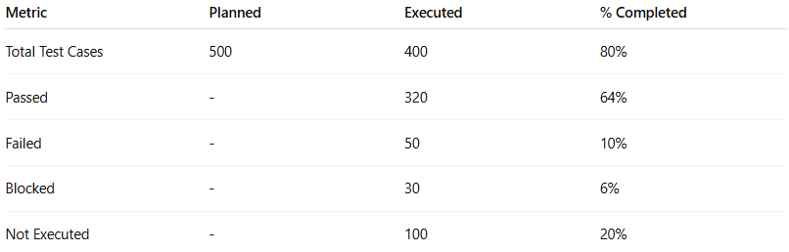
Metric | Planned | Executed | % Completed
Total Test Cases | 500 | 400 | 80%
Passed | - | 320 | 64%
Failed | - | 50 | 10%
Blocked | - | 30 | 6%
Not Executed | - | 100 | 20%
Defect Summary:
- Total Defects: 65
- Open: 25 (5 Critical, 10 Major, 10 Minor)
- Fixed/Closed: 40
Coverage:
- Requirements covered: 85%
- Modules tested: Login, Payments, Transfers
- Pending: Reports, Notifications
Risks/Issues:
- Test environment downtime slowed execution.
- 2 critical defects still unresolved.
Next Steps:
- Retest fixed defects.
- Continue execution of pending modules.
- Prepare regression suite for next cycle.

👥 Audience of Test Progress Report
# Source: Chatgpt (GPT-5-Standard) at [8/18/2025]
- QA Manager / Test Lead → Monitor daily/weekly execution.
- Project Manager → Check if project is on track.
- Developers → See defect trends and priority issues.
- Stakeholders/Clients → Get confidence on product quality.

✅ In short:
A Test Progress Report = a snapshot of testing status (how many tests run, pass/fail rates, defect trends, risks, coverage) → helps stakeholders see whether the project is on schedule and product quality is improving.

